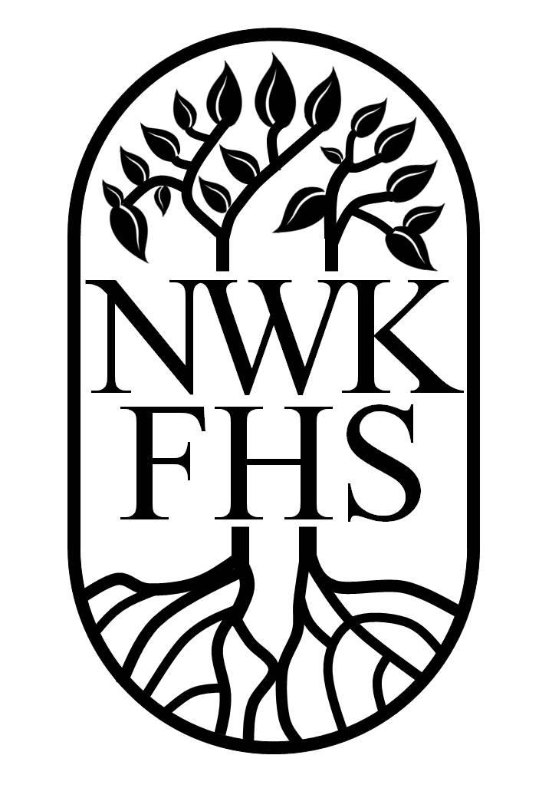

North West Kent
Family History Society
(N.W. Kent and ancient Kent parishes now S.E. London incorporating TWFHS)

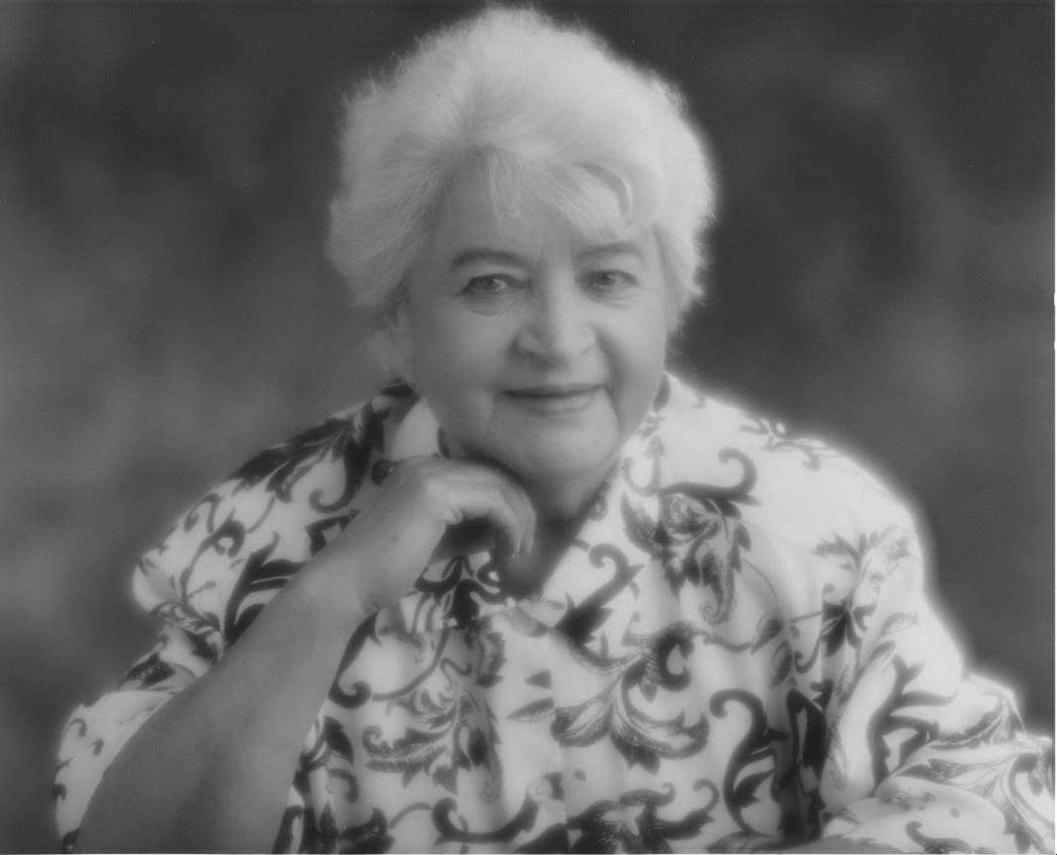

JOSEPHINE BIRCHENOUGH nee Redhead (1920 - 1994).

Josephine Birchenough Memorial Award.

Application Leaflet 2021.
Josephine Birchenough Memorial Award.

For the new members who do not know ‘Josephine Birchenough’, she was a founder member and her obituary repeated below shows how well she was respected by our members. She willingly gave fellow family historians help and encouragement from her prodigious knowledge and experience. This is why the Award was set up originally as a bursary to encourage members to share their research knowledge and experiences and help other family historians.

The bursary was set up in 1995 and has undergone a number of changes since. This is the current criteria and is for the judging and award from 2021 and presentation at the 2022 Annual General Meeting of the Society. If the AGM is not held for unforeseen reason as a face to face meeting, the notification of the winners will be made in the June Journal.

The Award is to have three categories that are to be judged by the President’s Panel, comprising the President, Vice-Presidents, Chair and Vice-Chair of the Society and chaired by the President.

If there should be an even number of votes for one or more award under any category the Vice-Chair of the Society shall have a deciding vote. In the absence of the Vice-Chair the President of the Society shall have the deciding vote. The quorum of the Presidents panel shall be any 3 of its members.

The three award categories being ‘Family History Project’, ‘Articles in the Society Journal’ and a general category, which recognises or supports significant work that contributes to the Society’s objects as outlined in clause 2 of the constitution.

Clause 2 Objects are:
2.1 The objects of the Society shall be to promote and encourage education in the study of family history and genealogy in relation to national and local history. In furtherance of the above mentioned objects the Society shall: -
2.1.1 arrange programmes of lectures, visits and other activities;
2.1.2 promote the preservation of relevant documents and records, locate, transcribe, index them and, wherever possible, publish the results;
2.1.3 provide guidance in family history research and studies;
2.1.4 do all lawful things necessary to advance the objects of the society.
The three award categories.
1. Project.
Awarded to a person or persons who wish to follow some form of research or carry out a specific family history project, which fulfils the objects of the Society.

Members wishing to be considered for this award need to complete an application form to be submitted to the President. Such applications can be made at any time. The decision on the project will be made within six weeks of receipt of the application. If the application is successful the sum of the award will be confirmed at this time. Announcement of the award will be made at the following AGM or the June Journal and must be used during that calendar year. The project is to be written up so as to report its progress to the Presidents Panel. This report should be edited to appear in the Journal confirming the research done and the results found.

The Award is to be open to any member of the Society (except the trustees and President’s panel) who has paid at least the subscription for the year of application and the year of the Award.
2. Articles in the Society Journal.
The President’s Panel will judge what they consider to be the best articles from the previous year's journals based on some if not all of the following criteria or variations on these themes.
1. An interesting read with substantial content written in a coherent style.
2. Method: how research is approached and the steps taken to discover the information.
Josephine Birchenough Memorial Award cont’d.
3. Sources: exact references and where located.
4. Confirmation: how the details were confirmed.
5. Problems: how overcome and comments on pitfalls.
6. Draw simple family tree(s) by hand or by computer to illustrate the family. The use of diagrams, photographs and illustrations is a useful explanatory tool. The copyright must be with the author.
7. Background to bring the story alive and set it in a wider context.

No application by a Member is required for this category to be considered for the award. The Presidents Panel will choose articles from the Society Journal editions published in the preceding 12 months. The award will be made annually at the AGM or announced in the June Journal. In addition to the monetary award, letters of commendation can be awarded. At each AGM and in the June Journal the President will report to the Society outlining the criteria used for this category.

3. To recognise or support significant work that contributes to the Society and its objects.

Recommendations for such an award can be made to the Society Committee or the Presidents Panel by any two members; a proposer and seconder. The Society Committee will refer the application to the President’s panel for judging the application.

The President’s Panel will consist of the President, Vice-Presidents, Chair and Vice-Chair of the Society. The Committee will be chaired by the President of the Society. If there should be an even number of votes for one or more award under any category the Vice-Chair of the Society shall have a deciding vote. In the absence of the Vice-Chair the President of the Society shall have the deciding vote. The quorum of the Presidents panel shall be any 3 of its members.

General:
1) No Society Committee member (Trustee) will be considered or eligible for or be given a financial award under any of the Memorial categories.
2) The Presidents panel members are not eligible for any of the awards.
3) These revised rules for the awards were agreed by the Trustees and are to be used by the President’s panel for the 2020 Awards and thereafter.

Application for the Josephine Birchenough Memorial Award.

Applicants Name and Address …………………………………..………………………………………………………………………………………………………………………………………………………………………………… Post Code ……………………….
Membership No- ……………………………… Telephone No. ………………………………………………….
Please state the purpose for which the Award will be put …………………………………………………
Please state why your ‘’Family History Project’ fulfils the objects of the Society, ……………………… ………………………….…………………………………………………………………………………….….. .................................................................................................................................................................. Please indicate the form of research you plan to undertake.................................................................... ………………………………………………………………………………………………………………………
Please indicate⁻if you are an amateur or professional researcher. ………………………………………………………………………………………………………………………
Please confirm that you understand if you are a successful applicant then you will be required to report on your project and that it may become an article in the Journal or a talk to one of the Society meetings.
If you will require help with preparing the report on your Award project please indicate what form of support you will need. …………………………………………………………………………………………
Signature of: applicant …………………………………………. Date………………………………..
Please hand this application to any member of the President’s Panel or Send to:- President, North West Kent Family History Society, C/O KCC Library, 80 Summerhouse Drive, Joydens Wood, Bexley, Kent DA5 2EE. Alternatively it may be emailed to president@nwkfhs.org.uk.
JOSEPHINE BIRCHENOUGH nee Redhead (1920 - 1994).

Josephine Birchenough was a remarkable lady. A woman of many parts: deeply involved in local and family history, speaking French and excellent Polish, her smattering of Mandarin and Russian reflecting her travels in advanced years, travels that included visiting her birthplace Australia. She was caring and thoughtful, giving generously of herself to anyone who needed her help. Josephine made an indelible impression on everyone.
With husband, Edwin, she worked on archaeological digs and made an exhaustive study of Lee in Kent to become the expert on Lee history, her notes and indexes carefully preserved. Documentation of her families, some parts of the story written up, has been preserved for posterity.
A founder member of this Society, Josephine immediately volunteered writing copiously for the Journal and regularly recording monumental inscriptions. On the Publications Committee she was invaluable, particularly in preparation of ‘West Kent Sources’, working prodigiously for the forthcoming publication on schools' records. Any Society activity involved Josephine in some capacity, described by a long-standing friend and member as "a jolly good soldier". Later, with the Society Committee, setting up Dartford Branch, chairing and training a group of willing volunteers new to family history and committee work.
By chance she learned and perfected a new skill, typesetting, one that enhanced our Journal (and others) for several years. It is fitting that Josephine had been made an honorary member of the Society.
The energy of the woman, even in later years, was remarkable, adding to her activities work such as indexing WO 97 army records for the Public Record Office project and taking groups to main repositories. So many will benefit in future from her work without ever knowing her; that would have pleased her. With considerable pride she accepted The Institute for Historical Research's honour for her work in local history and, at 70, was particularly happy at passing examinations for Licentiate of the Institute of Heraldic and Genealogical Studies.
Josephine could be exasperating (her words) whether determined to do things her own way or by refusing to curtail her activities after four serious throat operations, despite her 70 years. Generally philosophical, sustained by a strong Christian faith, Josephine was so independent but always genuinely grateful for help from others; always true to her own belief, fiercely defending whatever she felt to be right.
A real character, eccentric, Josephine arrived on her motor bike for most events until she was 70, a matronly figure in bright yellow waterproofs "her crash helmet framing those rosy cheeks", all removed to reveal her “Hell's Granny" I shirt, reflecting her modern and optimistic outlook. As an adult education tutor of family history Josephine "taught with such a great sense of humour and enthusiasm" inspiring students, recruiting members. She delighted in seeing fledgling family historians grow in confidence and expertise in their quest for ancestors. We shall remember Josephine for "her memory over a casual remark, producing pertinent references, within days: As friend, colleague or member we shall miss "this Wonderful lady, Josephine with her love of life", miss seeing her living it to the full.

From NWKFHS Journal Volume 6 No 10, July 1994

